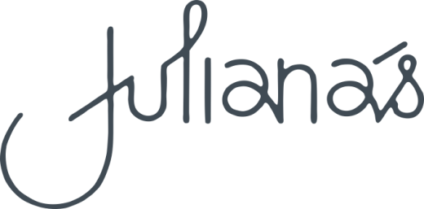

Entrées

Garlic bread $8 for one / $15 for two
Turkish loaf toasted with garlic, butter and parsley GFA, V

Creole prawns $19
Creole prawns, green pepper and tomato served with toasted Turkish loaf
GFA, DFA

Green lipped mussels $19
Grilled green lipped mussels, chorizo, garlic with a herb butter crumb

Bruschetta $19
Garlic toast with prosciutto de Parma, ricotta, cherry tomato and evoo VA

Caesar salad $19
Baby cos lettuce, homemade croutons, shaved parmesan,
grilled bacon and anchovy dressing GFA add chicken $7

Chicken bites $19
Southern fried with chilli honey and ranch dip
Beef sliders $19
Beef brisket slow cooked with BBQ sauce and slaw

V = vegetarian VA = vegetarian available GF = gluten free DF = dairy free

GFA = gluten free available DFA = dairy free available
If you have any special dietary requirements
please ask our friendly staff who can assist with your selection.

Please note 15% surcharge will apply on public holidays.

Mains

Caesar Salad $26
Baby cos lettuce, homemade croutons, shaved parmesan,
grilled bacon and anchovy dressing GFA add chicken $10

Bami Goreng $28
Stir fried noodles, tofu, cashew and chilli crunch V

Potato gnocchi $30
Homemade potato gnocchi with sage brown butter, roast squash,
green peas and toasted pine nuts V

Beer battered fish and chips $38
Served with slaw and tartare sauce

Crumbed chicken $39
Free range chicken breast crumbed with rocket salad, shaved parmesan,
roasted garlic aioli and potato of the day

Pork Tenderloin $44
Freedom farm pork tenderloin medallions with apple brandy green peppercorn cream,
seasonal vegetables and potato of the day GF

Lamb Shank $44
Red wine braised lamb shank with Colcannon potato, squash and gremolata GF

Fish of the day $44
Pan fried locally sourced fresh fish with saffron aioli,
seasonal vegetables and potato of the day GF DF

Rib eye $47
Chargrilled 300g prime angus rib eye served with garlic butter,
seasonal vegetables, potato of the day, and red wine jus GF DFA

Sides

Fries $ 9
Fries with garlic butter and gravy $10
Fries tossed in truffle oil topped with parmesan $12
Potato of the day $ 9
Seasonal vegetables $ 9 Seasonal green salad $ 9
Fried free range eggs $ 9

